**Setup the lab environment**

**⏱️ The estimated time to complete this lab is 60 minutes.**

**WWL Tenants - Terms of Use**

If you are being provided with a tenant as a part of an instructor-led training delivery, please note that the tenant is made available for the purpose of supporting the hands-on labs in the instructor-led training. Tenants should not be shared or used for purposes outside of hands-on labs. The tenant used in this course is a trial tenant and cannot be used or accessed after the class is over and are not eligible for extension. Tenants must not be converted to a paid subscription. Tenants obtained as a part of this course remain the property of Microsoft Corporation and we reserve the right to obtain access and repossess at any time.

**Introduction**

Let’s get started. In this first lab, you will acquire a Power Platform trial tenant and access the Power Platform admin center. In the admin center, you will create the environments for use during the course.

You will also see the Power Automate Desktop application and install .NET and Browser extension pre-requisities which are required for the remainder of the course.

**Exercise 0 – login**

Log into the VM using the already selected Admin account and the last password in the bottom of the page under Resources tab per my screenshot above.

**Exercise 1 - Acquire your Power Platform trial tenant**

1. Your **Microsoft / Office 365 credentials** are also provided under Resources tab per my screenshot above.
2. In a new browser tab, navigate to https://powerapps.microsoft.com and select **Start free**.

1. Enter the email address from your Microsoft / Office 365 credentials.
2. You see a prompt that you have an existing account with Microsoft. Select **Sign in**.
3. Enter the password provided by the Authorized Lab Hoster. Here’s an example of my Admin credential:

1. Select **Yes** to stay signed in.
2. If prompted to register, enter 0123456789 as Business phone number and complete the sign up process by selecting **Get Started**.
3. To confirm the details, select **Get started** again.
4. PowerApps will load in a new tab.
5. Following the Welcome prompts.

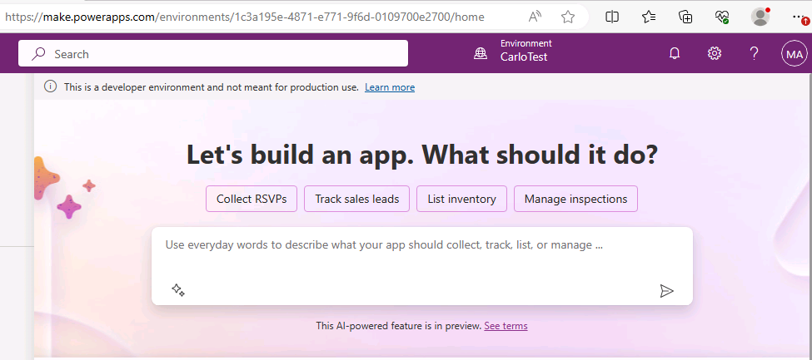

**Exercise 2 - Create your environments**

In this exercise, you will create your Development and Test environments that you will do the majority of your lab work in.

**Task 1 – Create Development environment**

1. Open a new tab, navigate to https://powerapps.microsoft.com/en-us/developerplan and select **Existing user? Add a dev environment**, log in with your Microsoft 365 credentials if prompted again.

Then click on Start Trial:

Choose United States as your country and click on Accept:

1. Select **Accept**.
2. Your **Dev** environment should now show in the list of Environments. This typically is named **MOD Administrator’s Environment**. For the rest of this course when it says Dev environment it will be referring to this environment.

Note: It might take a couple of minutes for the new environment to be provisioned and become available in the list of the environments. You can see the progress of the environment creation in the [Power Platform admin center](https://admin.powerplatform.microsoft.com). You can proceed with the rest of this lab while the environment is provisioned, it must be finished before you start the next lab.

In my case, you can see my environment on top “CarloTest”:

But I have created many environments as I was helping students today. You could always do the same if needed:

**Task 2 – Create a Test environment**

1. Open a new tab, navigate to https://aka.ms/ppac and log in with your Microsoft 365 credentials if prompted again and select **Get Started**.

Here’s what you will see:

Click on Environments and you will see +New:

1. Select **Environments** and select **+ New** from the command bar.
2. For **Name**, enter **[my initials] Test** (Example: AJ Test)
3. For **Type**, select **Trial**.
4. Change the toggle on **Add a Dataverse data store?** to **Yes**.
5. Leave all other selections as default and select **Next**.

I have circled all the steps for you:

1. On the **Add Dataverse** tab, using the **+ Select** button under **Security group**, select **None** and then select **Done**.

I have circled +Select:

Click +Select and you will see the following screen, click the yellow circles:

1. Select **Save**:

1. The **Test** environment should now show in the list of Environments.

**Note:** The environment may take a few minutes to provision. Refresh the **Environments** list if needed. When your environment shows as ‘Ready’, select the **Test** environment by selecting the ellipses menu and selecting **Settings**.

1. Explore the different areas available in **Settings** but do not make any changes yet.

**Exercise 3 - Power Automate Software**

In this excercise, you will be configuring Power Automate Desktop and accompanying applications.

**Task 1 - Configure Power Automate Desktop**

Power Automate Desktop is installed by default on Windows 11, but you will need to sign in and configure the environment.

1. Search the **Start** menu for Power Automate and open the **Power Automate** app.

Or simply double the circled icon on your VM’s desktop:

1. When Power Automate Desktop opens, sign in using your Office 365 Tenant credentials. Select **Next** and **Get started**.

I have highlighted the credentials for you:

Optional: Select **Start tour** and go through the welcome prompts to get a feel for the application.

1. From the **Environments** list, select your **Dev** environment.

**Task 2 - Configure the Power Automate Machine-Runtime App**

To run attended and unattended flows across cloud and desktop environments, the **machine-runtime app** needs to be configured.

1. In Power Automate Desktop, select **⚙️ Settings**. Under Machine settings, select **Open machine settings**.

I have highlighted the location of Settings for you:

Here’s where you click next circled in yellow:

If asked for updating Power Automate, feel free to X out:

1. On the **Machine settings** screen, select your **Dev** environment. The machine-runtime app will register the machine in the Dev environment’s Dataverse database. You should see a success notification “Your machine XXXXYYX has been registered”.

Here’s how it looks like:

**Note:** If you get an error stating a premium license is required, in the message select the Get Premium option and start a trial.

1. Once it’s connected, you can close the **Power Automate machine runtime** window.

**Exercise 4 - Azure account setup**

In this exercise, you will create your Azure account that you will be using in the labs.

1. Use the Promo Code provided in the lab for the next step, I have added a screenshot:

1. Use a private browser session, go to Microsoftazurepass.com to redeem your Azure Pass using the Microsoft 365 credentials provided to you). [Redeem a Microsoft Azure Pass](https://www.microsoftazurepass.com/Home/HowTo?Length=5) Follow the instructions for redemption.

Here’s how to open a private browsing session in Edge:

And here’s how private window looks like:

Here’s what to do next:

Login:

And next:

Here’s what to do next:

Next, remove the Name and Last name Admin and input an actual first and last name.

Also, provide a real US Address. Submit.

After the account setup completes, setup the following Virtual Machine.

1. Navigate to https://portal.azure.com
2. Select **+ Create a resource**.

Here’s how it looks like:

1. Select **Create** Virtual Machine.

[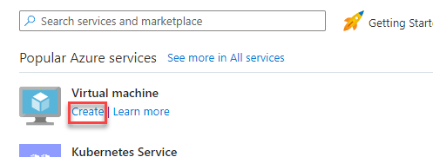](https://microsoftlearning.github.io/PL-500T00-Microsoft-Power-Automate-RPA-Developer/Instructions/L00/media/image1.png)

Here’s how it looks like:

1. Select **Create new resource** group.

[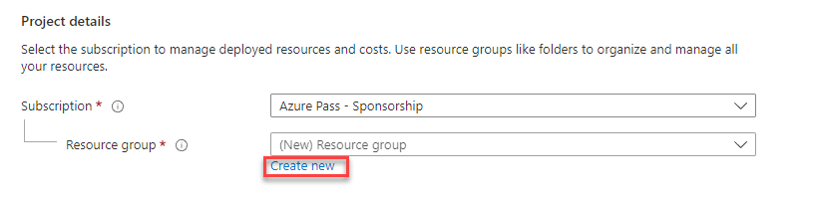](https://microsoftlearning.github.io/PL-500T00-Microsoft-Power-Automate-RPA-Developer/Instructions/L00/media/image2.png)

1. Enter Funding for **Name** and select **OK**.

Here’s how it looks like:

1. Enter Funding for virtual machine name.
2. Select **Windows 11** Image.
3. Enter Funding for Username.
4. Create a secure password and make a note of it.
5. Confirm the Password.
6. Check the box for *I confirm I have an eligible Windows 10/11 license with multi-tenant hosting rights.* under **Licensing**.
7. Select **Review + create**.

[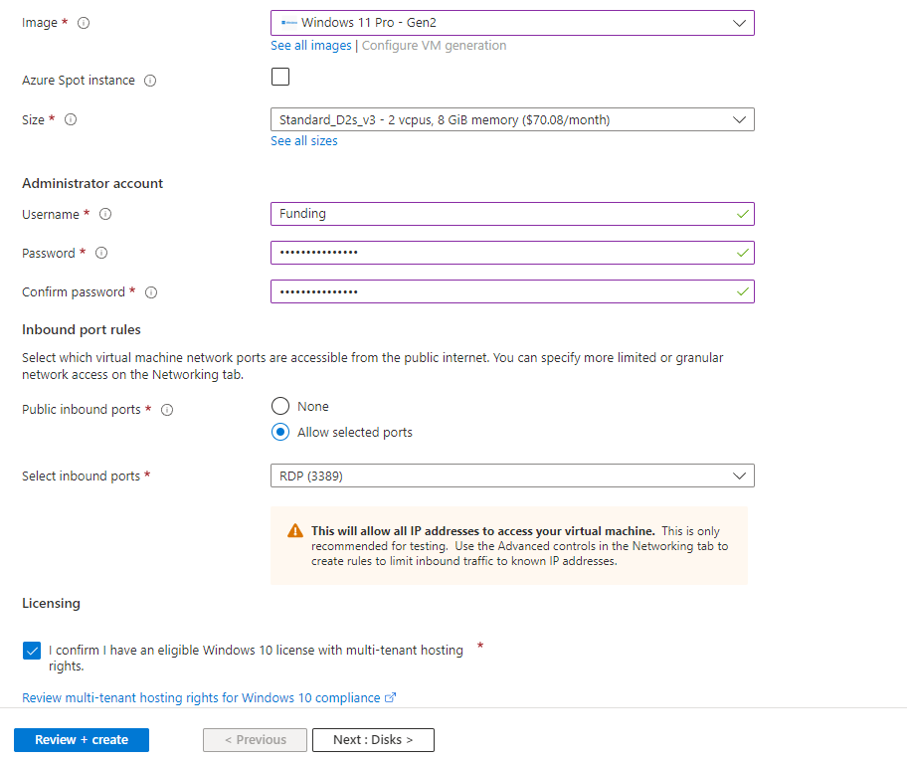](https://microsoftlearning.github.io/PL-500T00-Microsoft-Power-Automate-RPA-Developer/Instructions/L00/media/image3.png)

Here are the steps in detail:

Make sure you search for and select the same Image I have selected as you see in my screenshots above and below this line:



1. Select **Create**.

**Exercise 5 – Copy Lab Resources**

1. Create a folder **Labs** on the **C:** drive if you don’t already have that folder.
2. Copy the lab resources folder to **C:\Labs** if it doesn’t already exist.
3. Browse to **C:\Labs\Resources\Funding manager app** and double-click on the **Woodgrove Bank Funding Manager.exe** file.

Here are the steps:

And then:

1. Select **Yes** on the download .NET popup.

[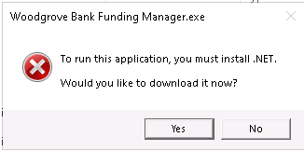](https://microsoftlearning.github.io/PL-500T00-Microsoft-Power-Automate-RPA-Developer/Instructions/L00/media/image5.png)

1. Select open file on the downloaded .exe file in the browser downloaded file list.
2. Select **Install** and wait for the installation to complete.

[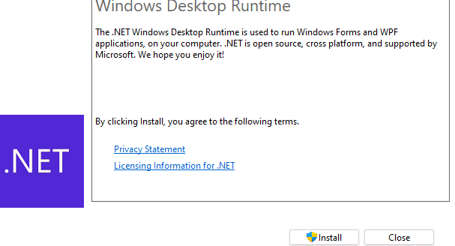](https://microsoftlearning.github.io/PL-500T00-Microsoft-Power-Automate-RPA-Developer/Instructions/L00/media/image7.png)

1. Select **Close** after the installation completed.
2. Browse to **C:\Labs\Resources\Funding manager app** and double-click on the **Woodgrove Bank Funding Manager.exe** file again.

[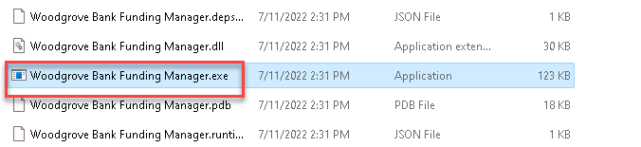](https://microsoftlearning.github.io/PL-500T00-Microsoft-Power-Automate-RPA-Developer/Instructions/L00/media/image8.png)

Once the Woodgrove app opens, use your O365 Admin username and pass@word1 for password:

1. The app should launch. **Close** the application.